Homework Week 5:

**DUE Monday Oct 2, PRIOR to Class. Submit to Blackboard by the due date AND submit hardcopy in class on Monday, Oct 2. You must submit a hardcopy showing your work for part 5 before any credit will be earned for that portion of the homework.**

**Part 1:** Honesty Statement:

I ___________Josh Howard_____________ [Insert your name] agree that I will complete this assignment **without** the aide of another student. I understand that I **may** use any course notes that I have taken, any available course material on blackboard and other reference materials, such as the Internet or computer science texts. I understand that I can also seek professional assistance, such as the Instructor or tutoring lab assistants, but will attempt the assignment on my own first.

**Part 2: Essay questions, ensure to include a minimum of 1 reference to earn full-credit.**

1. Explain Moore’s Law (who and when was it stated, as well as what it means). Minimum of 5 sentences and 1 external reference. [5 pts]

Moore’s law was said by Gordon Moore in 1965. It states that the number of transistor’s in an integrated circuit would double every year. Though in 1975, he revised his law to that the transistors would double every two year, not one. This has held true since he has said this to today. Though it has slowed down to doubling roughly every 18 months now.

http://www.investopedia.com/terms/m/mooreslaw.asp

1. Explain digital circuits. Minimum of 5 sentences and 1 external reference. [5 pts]

Digital circuits are circuits that are designed to have two different states, usually on/off (0/1). These circuits are what are used in processing chips. With the ability to be on/off, which represents the 0/1 in binary, these circuits can process and work with binary systems. They are used to make the logic gates that do the computations within the processing chips.

http://www.chegg.com/homework-help/definitions/digital-circuits-4

1. Review at least 1 Data sheet from the class presentation slides and provide details about what it contains. Include the link as the external reference. [5 pts]

The AND Gate Circuitry data sheet. The sheet shows the circuit that’s actually inside the AND gate. Also shows how the analogue circuit for an AND gate works.

**Part 3: Short answer.**

1. How many digital logic states are there? ______2_______ [2 pts]
2. Approximately how many transistors are in a VLSI integrated circuit? ____ between 1,000 and 10,000 ________ [3 pts]

**Part 4: Truth Tables**

1. Write the truth table for the following five (5) digital logic gates. Except for the NOT gate, assume two (2) inputs and 1 output. [2 pts each]

|  |  |  |
| --- | --- | --- |
| A | B | Y |
| 0 | 0 | 0 |
| 0 | 1 | 0 |
| 1 | 0 | 0 |
| 1 | 1 | 1 |

|  |  |  |
| --- | --- | --- |
| A | B | Y |
| 0 | 0 | 0 |
| 0 | 1 | 1 |
| 1 | 0 | 1 |
| 1 | 1 | 1 |

|  |  |  |
| --- | --- | --- |
| A | B | Y |
| 0 | 0 | 1 |
| 0 | 1 | 1 |
| 1 | 0 | 1 |
| 1 | 1 | 0 |

|  |  |  |
| --- | --- | --- |
| A | B | Y |
| 0 | 0 | 1 |
| 0 | 1 | 0 |
| 1 | 0 | 0 |
| 1 | 1 | 1 |

NOT AND OR NAND NOR

|  |  |
| --- | --- |
| A | Y |
| 0 | 1 |
| 1 | 0 |

**Part 5: Given the following input values, what is the output of ‘f’**

1. Follow the flow of the Inputs a through g and determine the output ‘f’. **Most show work on hardcopy handed in during class. [20 pts]**

a. 1

b. 0

c. 1

d. 1

e. 0

f. 1

g. 0

Output f = ____1____________

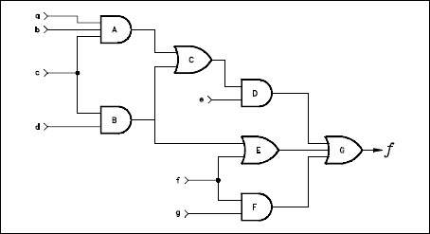

2. Follow the flow of the Inputs a through g and determine the output ‘f’. **Most show work on hardcopy handed in during class. [20 pts]**

a. 0

b. 1

c. 0

d. 0

e. 1

f. 0

g. 1

Output f = ______0_________



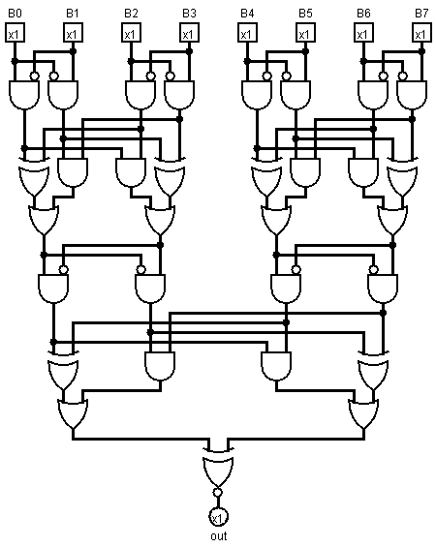

**Instructions: Follow the flow of the Inputs B0 to B7 and determine the output. Most show work on handed in copy. [30 pts]**

**Inputs:**

**B0 = 1**

**B1 = 1**

**B2 = 0**

**B3 = 1**

**B4 = 0**

**B5 = 0**

**B6 = 1**

**B7 = 1**

**Output:**

**____0___**

**NOTE: B0**